|  |  |  |
| --- | --- | --- |
|  | **METODO AGIES** |  |

|  |  |
| --- | --- |
| **CONSIDERACIONES GENERALES DE LA EDIFICACIÓN** | |
| **UBICACIÓN** | Departamento Sololá, Sololá |
| **USO** | Bodega |
| **NIVELES** | 3 |
|  |  |

* La estructura será diseñada con un sistema de marcos estructurales
* El método para realizar el análisis sísmico será el establecido por la normativa SEAOC

|  |  |  |  |  |
| --- | --- | --- | --- | --- |
| **Carga (kg/m2)** | **Viva** | **Sobre Losa** | **Bajo Losa** | **Sobre Carga** |
| **Techo** | 150 | 175 | 125 | 175 |
| **Entre Piso** | 250 | 175 | 125 | 275 |

|  |  |  |
| --- | --- | --- |
|  | **Vigas** |  |
| **Dirección** | Y | X |
| **Tipo** | V-A | V-1 |
| **Base (m)** | 0.3 | 0.3 |
| **Altura (m)** | 0.5 | 0.5 |
| **Area (m^2)** | 0.15 | 0.15 |

|  |  |
| --- | --- |
| **Columnas** |  |
| **Tipo** | C-A |
| **Base (m)** | 0.45 |
| **Altura (m)** | 0.45 |
| **Área (m^2)** | 0.2 |

|  |  |
| --- | --- |
| **Muros** |  |
| **W (kg/m2)** | 232.0377 |
| **Espesor t(m)** | 0.3 |
| **Longitud M1 (m)** | 1.5 |
| **Longitud M2 (m)** | 1.2 |
| **Área M1 (m^2)** | 0.45 |
| **Área M2 (m^2)** | 0.36 |

|  |  |  |  |
| --- | --- | --- | --- |
| **Elevador** | |  | |
| **Lado Corto 1 (m)** | | 1.75 | |
| **Lado Corto 2 (m)** | | 1.75 | |
| **Lado Interno 1 (m)** | | 4.35 | |
| **Espesor (m)** | | 0.3 | |
| **Área (m^2)** | | 2.355 | |
| **Losas** |  | |
| **t Critico (m)** | 0.13 | |

|  |  |
| --- | --- |
| **Datos de Concreto** |  |
| **F´c (kg/cm^2)** | 350 |
| **Peso Concreto W (kg)** | 2400 |
| **Modulo de elasticicdad** |  |
| **del concreto EC** | 282495.1 |
| **(kg/ m^2)** |  |
| **Modulo de Corte** |  |
| **EG = 40% EC** | 112998.05 |
| **(kg / m^2)** |  |
| **Peso en Toneladas** | 2.4 |

**PLANOS DE PLANTA Y ELEVACIÓN**

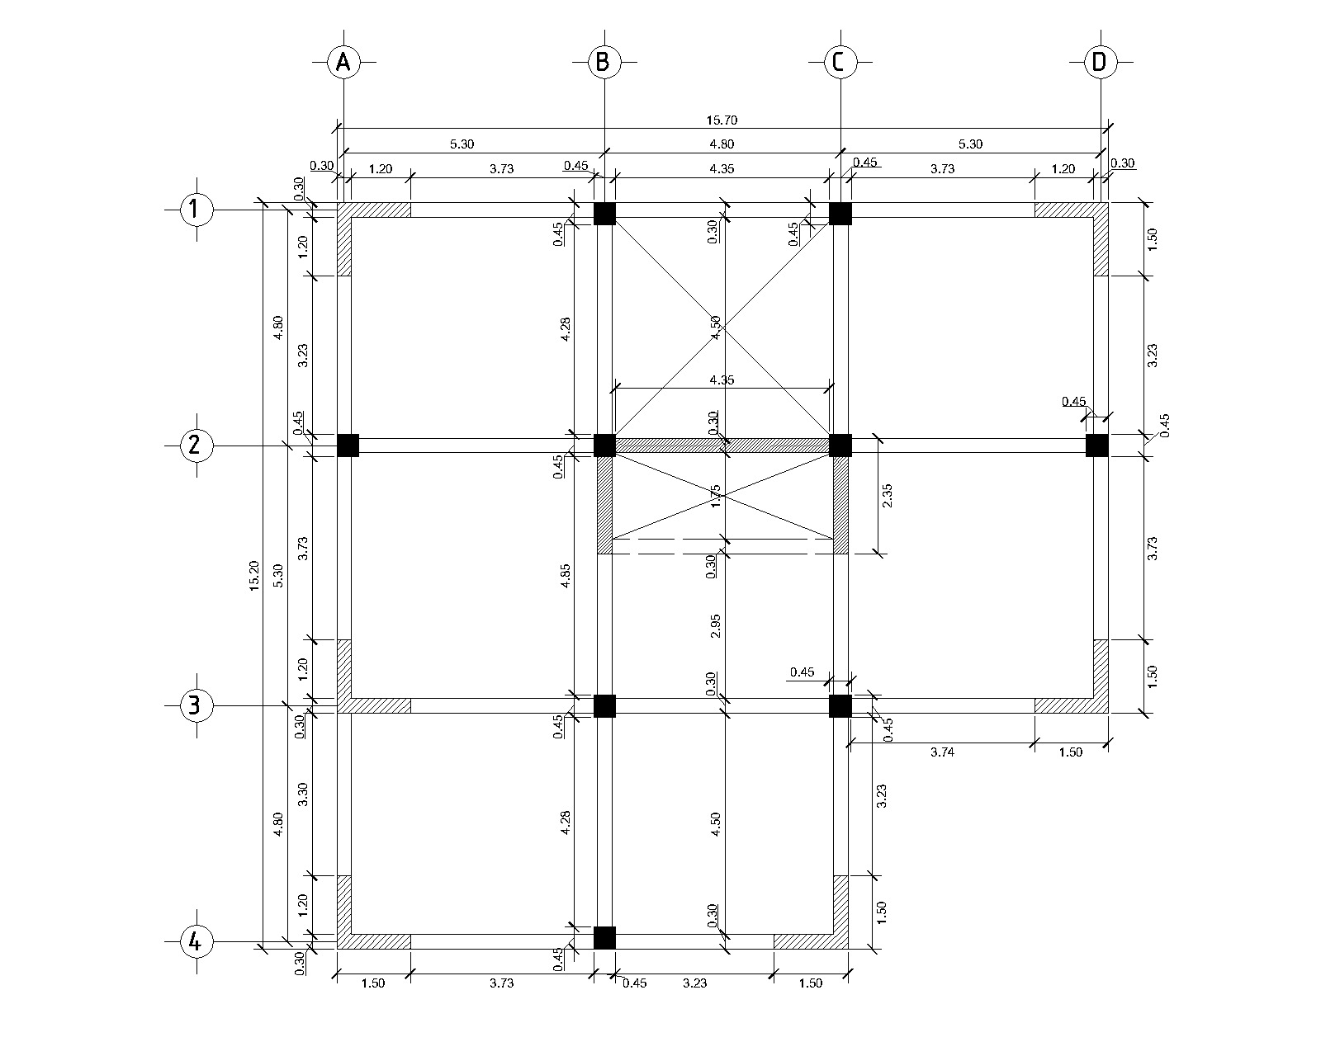

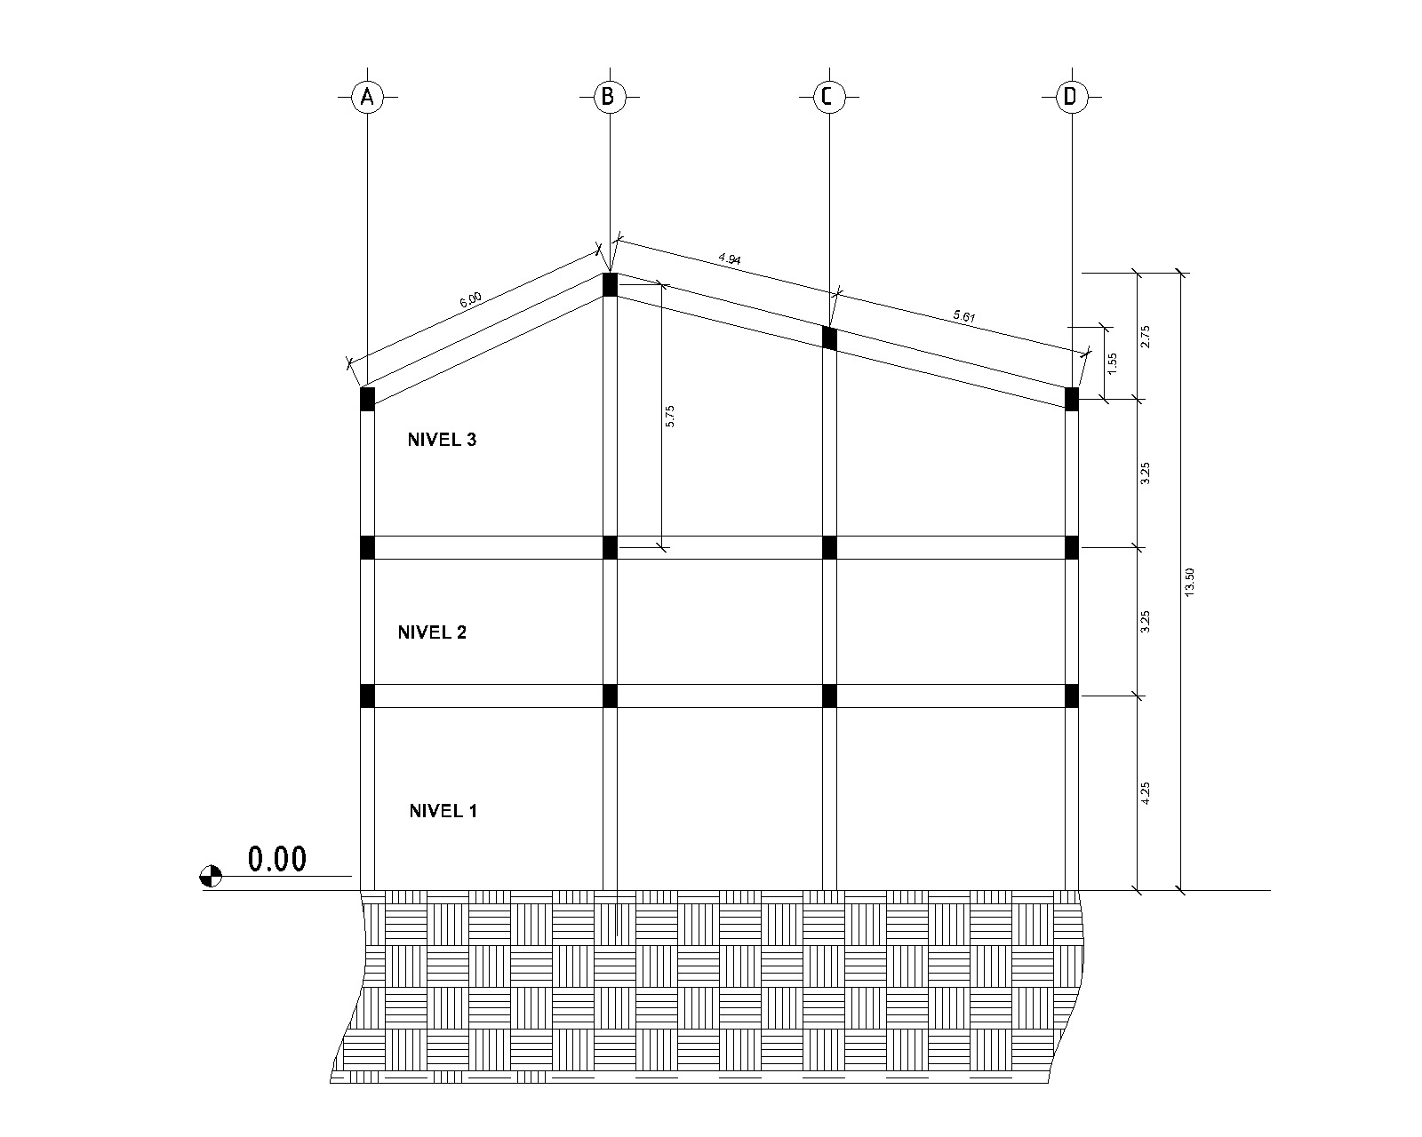**ELEVACIÓN**